Node API

**Copy Node**

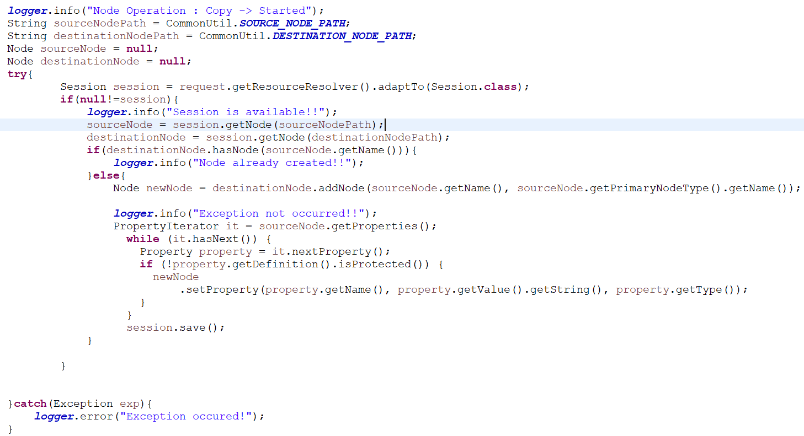

**Note:** Once the node is created and try to create the same node again, an exception would be thrown.

**Get node properties**

* Checking if the node is protected (non-editable)
* Check if the property value is single or multiple
* PropertyIterator
* Value[]
* Value

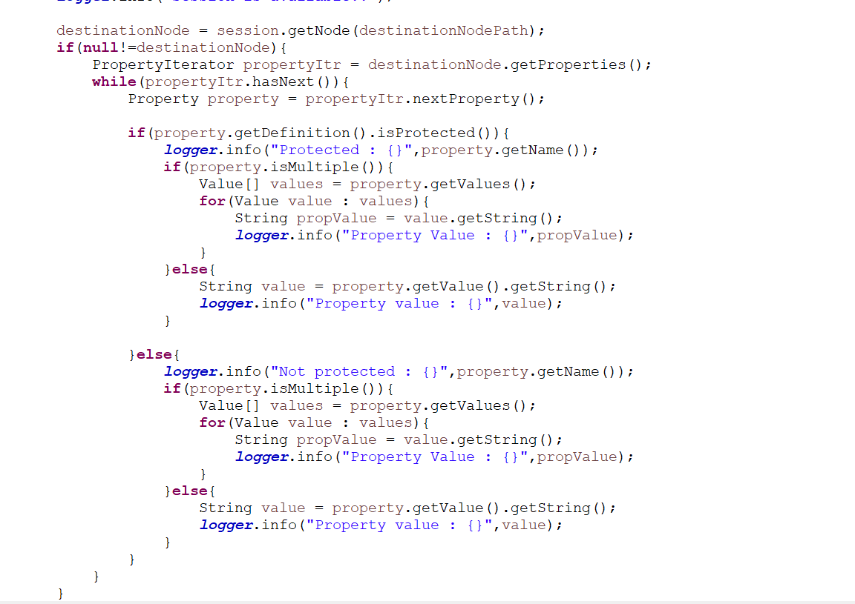

**Get child nodes if present**

